**Terraform Exercise**

**Problem**: As we know that terraform is an provisioning tool use to provision resource in the cloud.

**Solution**: We need to deploy an azure vm with local variable in terraform. Create a bastion host using terraform and using null provisioned upload the ssh key in bastion host. And connect the vm with those ssh key

**- Console Output**

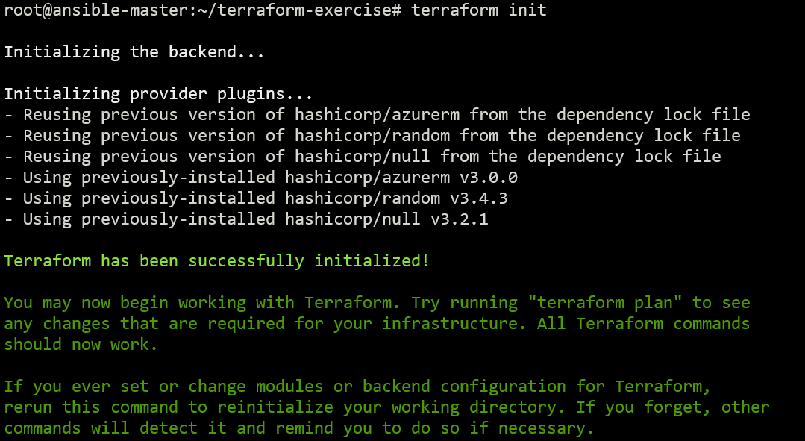

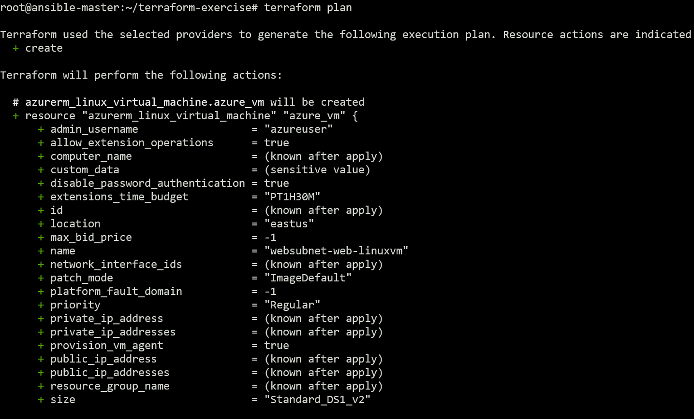

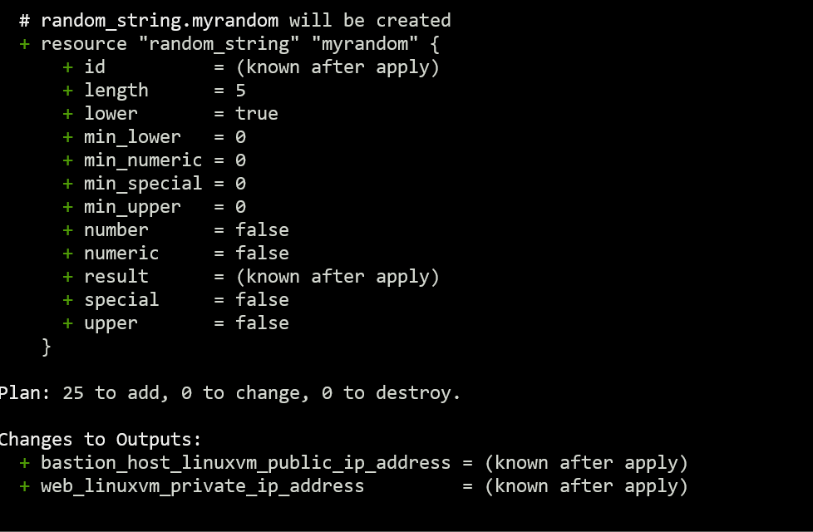

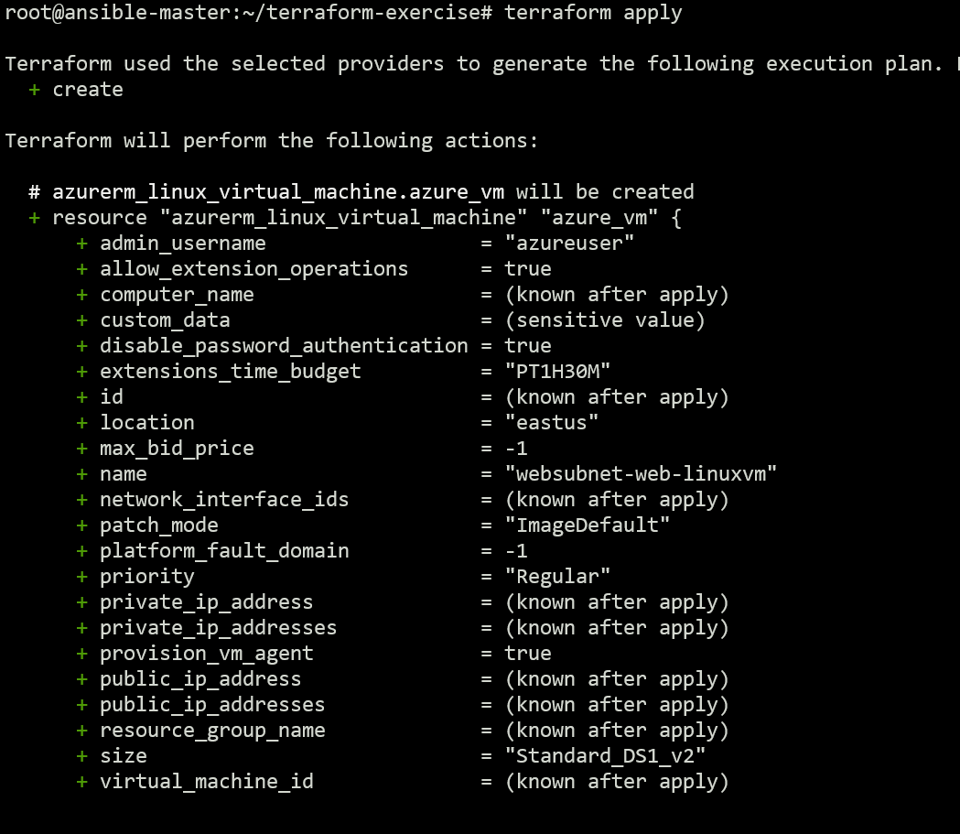

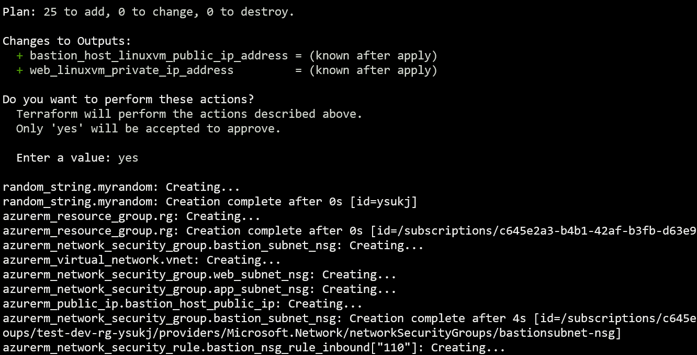

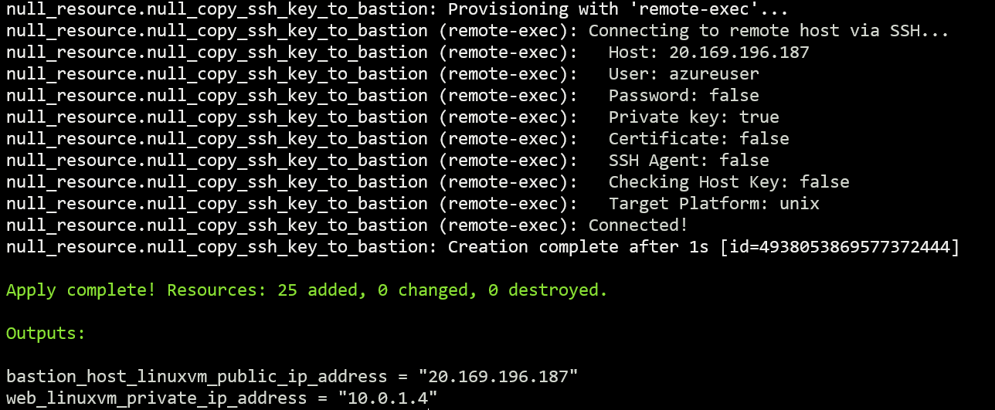

**-** ssh into bastion host

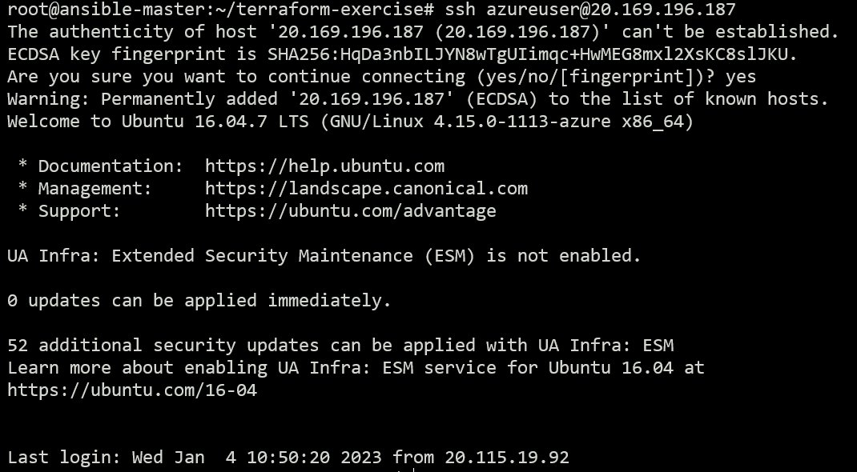

**-** ping web linux vm’s private ip from bastion host works as it is in same network.

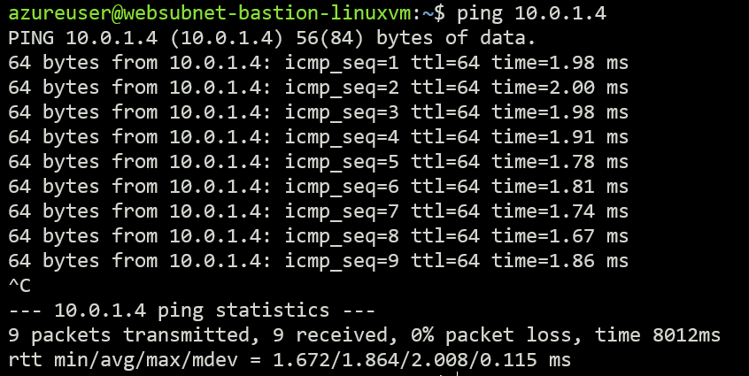

**-** ping from a vm outside of linux vm’s network is not working.

